Title of project: Scenario of Port city.

Group MEMBER

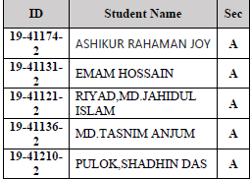

**Project Goal:** The aim of this project is to develop a 2-D graphics package which supports basic operations which include creating objects like lines, circles, polygons, spirals, etc and also transformation operations like translation, rotation, etc on such objects. The package must also have a user-friendly interface that may be menu-oriented, iconic or a combination of both.

**Introduction:** The project is about scenario of a port city. The instruments that used in the scenario are –train, car, windmill, air vehicle, ship, clouds, trees, birds, house, playground, river. Some of the components will move according to their characteristics.

**Software requirement specifications:**

**Platform used**:

* **Windows**

**Software Used:**

* **OPENGL**
* **CodeBlocks**

**Explanation:**

In short all the basic features necessary for the computer graphics have been provided. Care is taken to implement mouse, keyboard interaction to provide an intuitive feel to our graphics project.

**Scope:** It provides most the features that a 2D graphic editor should have. It is developed in Code Blocks C++. It has been implemented on WINDOWS platform. The 2-D graphics package designed here provides an interface for the users for handling the display and manipulation of basic picture objects like point, line, rectangle, circle, polygon etc. It can also perform operations on selected objects like translation, rotation etc. It is capable of loading and saving the picture files. The interface is user -friendly with icons for all the functions. The mouse and keyboard are the main input device used in this project.

**Hardware & Software Requirements:**

**Hardware Requirements:**

* Pentium or Higher processor.
* 2 GB RAM or More.
* A standard keyboard.
* Compatible mouse.
* VGA monitor

**Software Requirements:**

This graphics project has been designed for WINDOWS XP and higher Versions. OpenGL libraries are used and hence CodeBlocks v17.12 or later is required.

**Development Platform:** WINDOWS 10,

**Language Used In Coding**: CodeBlocks C++.

**Design & Features:**

1. Changing weather
2. Controlling train(start, stop, speed)
3. Controlling car(start, stop, speed)
4. Rotating windmill
5. Moving air vehicle
6. Day-Night changing
7. Moving ship

**Testing:**

Project is tested to ensure that, they operate correctly. In our project, the test was successful and ran perfectly.

**Result:**

**Day view:**

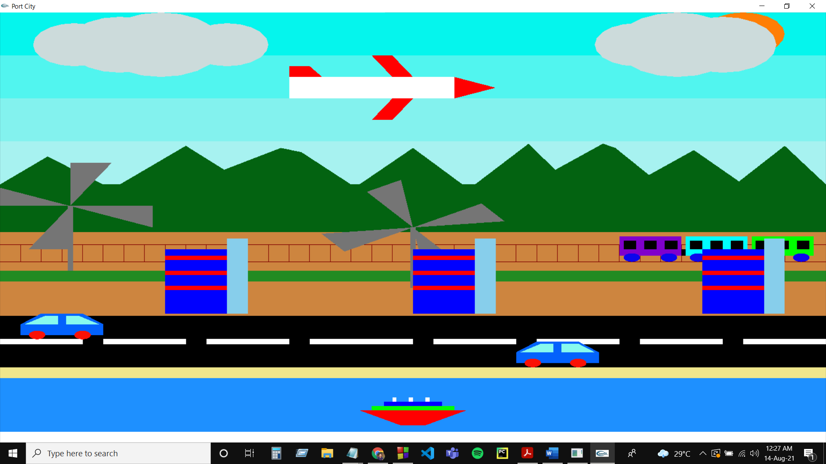

**Night view :** 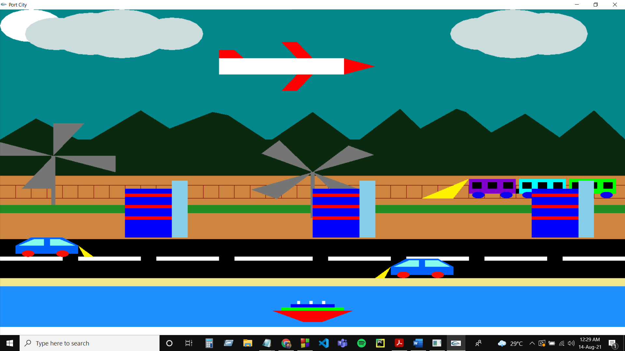

**Rain :**

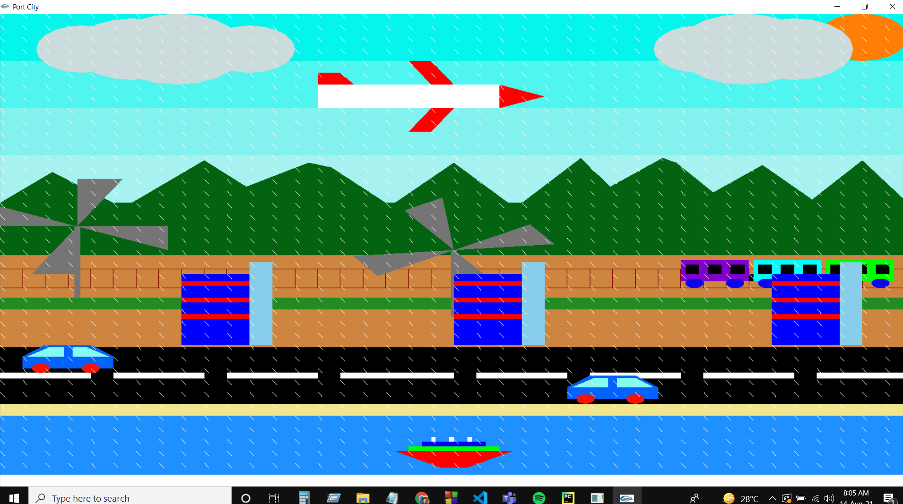

**Sun moving :**

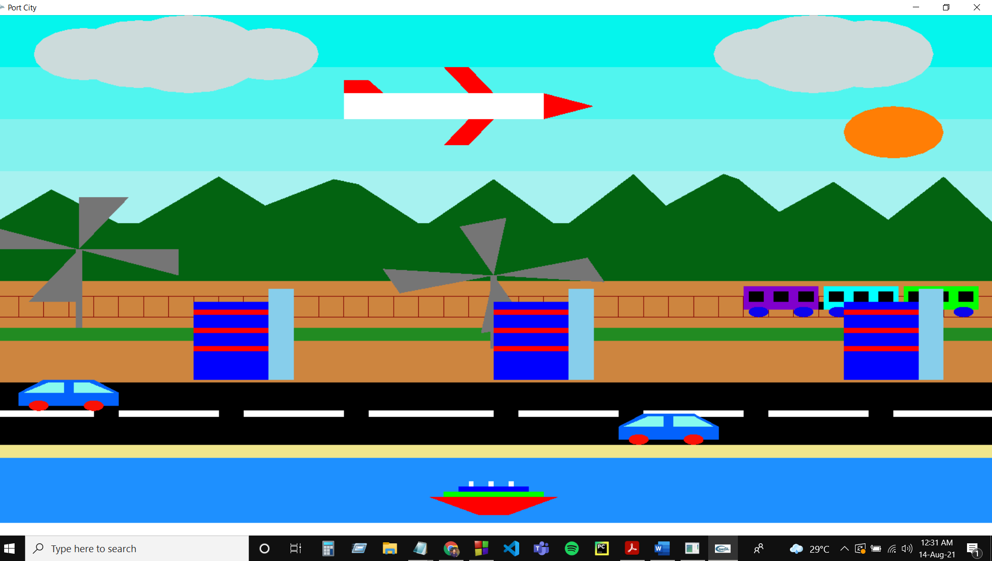

**Vehicle moving :**

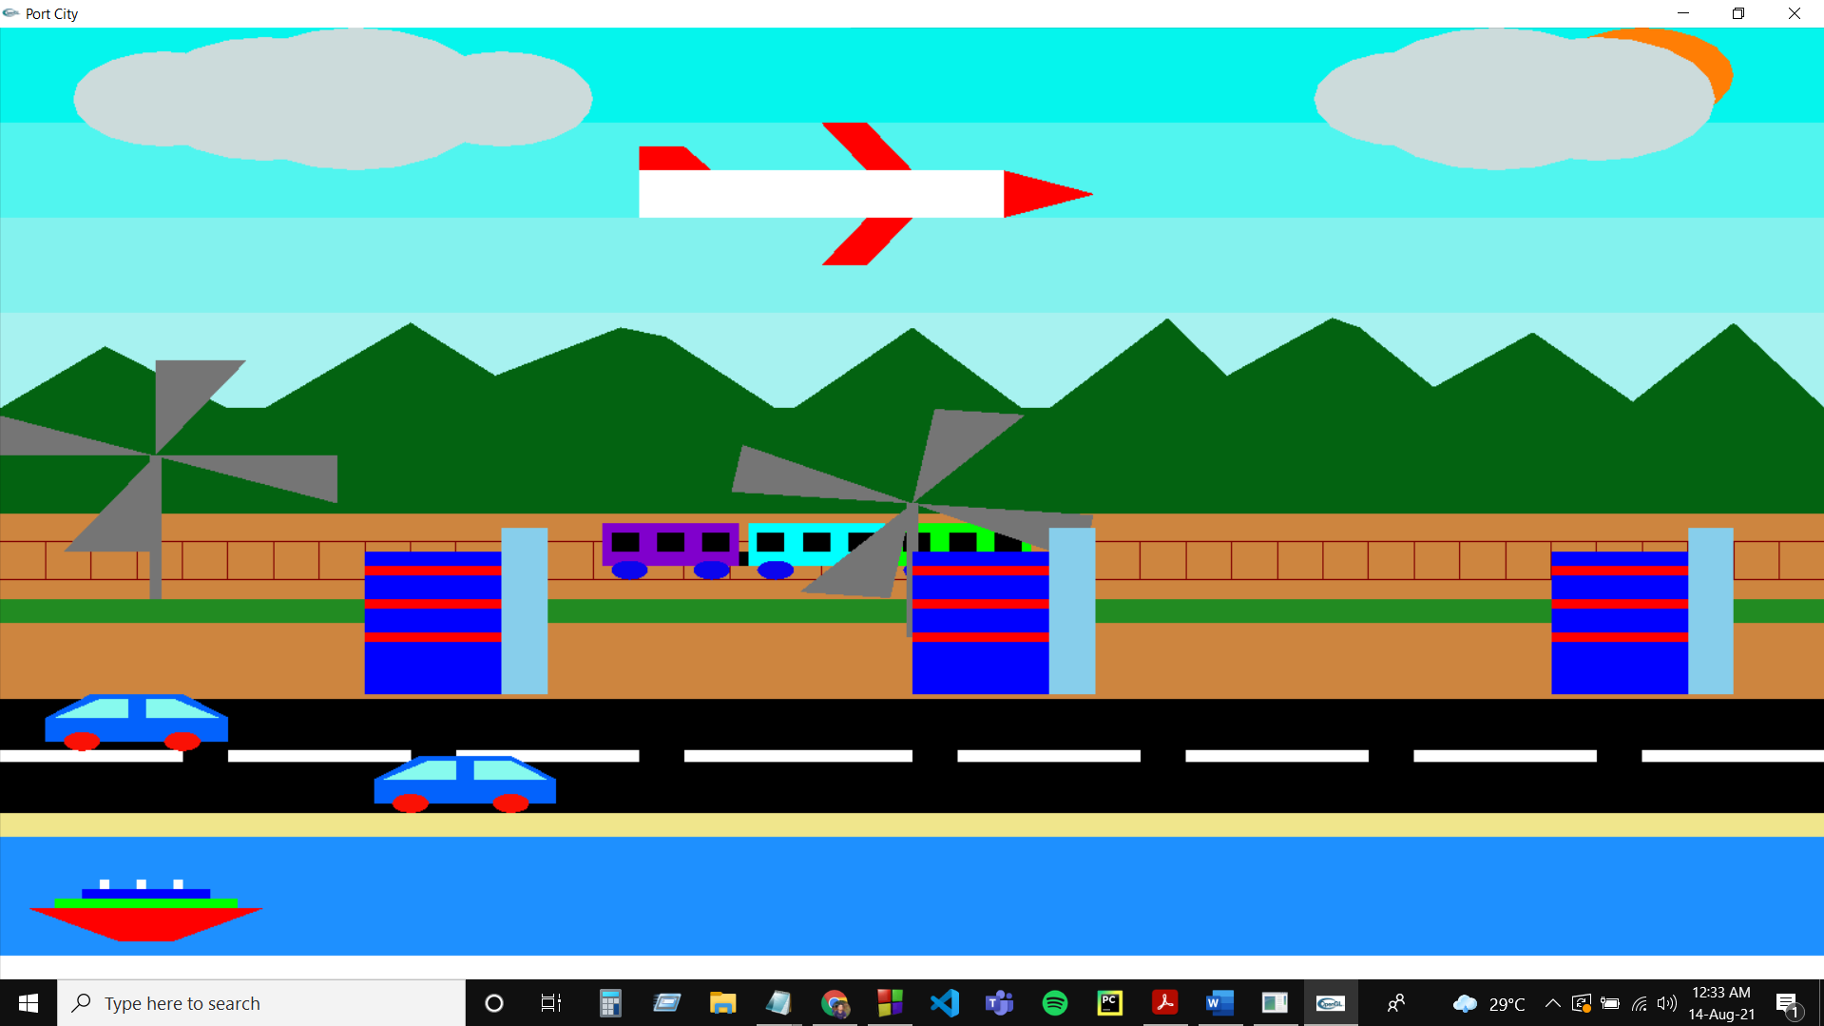

**Conclusion and Future Enhancements:**

Our graphics project is very user friendly interface. The user can very easily use this project to draw or manipulate a drawing. The interface is mouse, keyboard driven. For the user’s help, the function performed by each icon is displayed in the status bar as soon as the mouse pointer moves over the icon. We have tried our best to make this project very simple and easy to use, so that the user does not face any trouble when switching over from any real life graphics editor to this new one.

The following are some of the features that are planned to implement in the near future.

* The project currently is platform based, so it could be developed for open source.
* Features like "Undo" and "Redo" could be provided.
* The editor saves images in raw format and cannot load or save in standard image file formats such as jpg, jpeg, png, gif. Therefore Support for different file formats like jpg, jpeg, png, gif etc. could be provided soon.
* Support for advanced 3d transformations.
* Only Single Document Interface has been provided, multiple document interfaces can be provided.